**Laboratory Report   
DeVry University  
College of Engineering and Information Sciences**

**Course Number: DBM405A**

**Professor: Lively**

**Laboratory Number:** 3

**Laboratory Title:** Database Creation and Table Manipulation

**Submittal Date:** 5/23/2015

Note: There is no limit on how much information you will enter under the three topics below. It is important to be clear and complete with your comments. Like a scientist, you are documenting your progress in this week’s lab experiment.

**Objectives:** In your own words, what was this lab designed to accomplish? What was its purpose?

The main objective/purpose of this lab was to have us become familiarized with updating tables, and then loading and unloading values via use of comma-delimited files. In addition, we got further practice creating tables (creating the Season table) and also loading more insert statements in order to populate the table with data. The last point we touched on was practicing how to create a table based off the structure of another table, which was a new concept to me. We could either just keep the structure (column values) or the structure and the data as well, and in this instance I loaded the table and its data into the new table, then simply used an update to change the values of the desired column (season/year) to differentiate past and present seasons.

**Results:** Discuss the steps you used to complete your lab. Were you successful? What did you learn? What were the results? Explain what you did to accomplish each step. You can include screen shots, code listings, etc. to clearly explain what you did.

Please see the following code/screenshots with comment annotation for each number/step of the lab to see how each step was successfully achieved. Please note each highlighted step, and its ensuing successful output:

#1

create table Season

(

Season integer,

PlayDate date,

HomeTeam char(15),

HomeTeamScore integer,

AwayTeam char(15),

AwayTeamScore integer

);

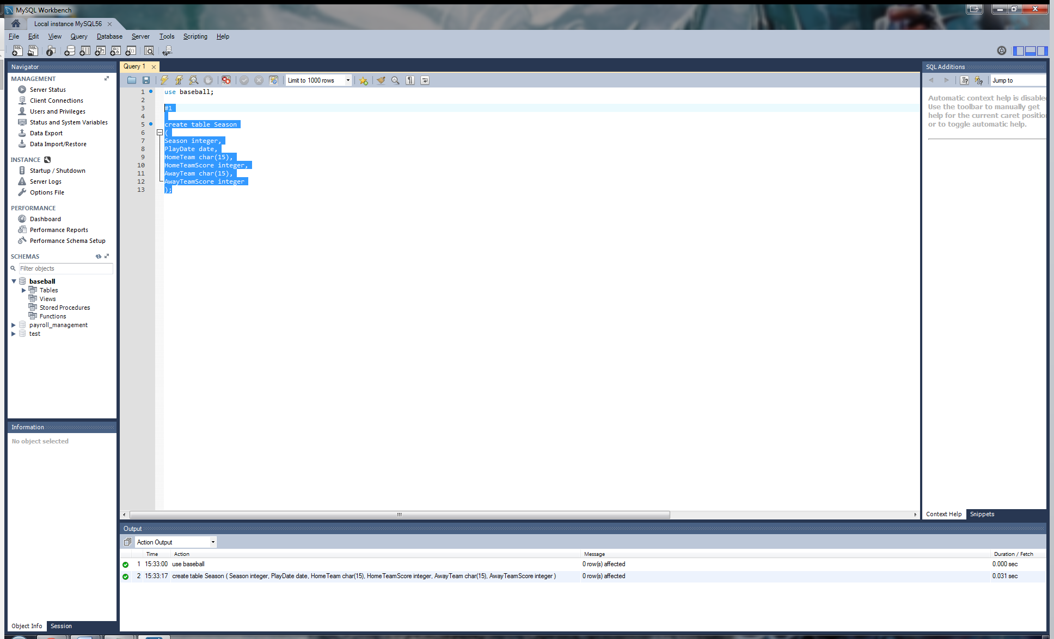

#2

Insert into Season

(Season, PlayDate, HomeTeam, HomeTeamScore, AwayTeam, AwayTeamScore)

Values

(2015, '2015-01-01', 'No Fighters',NULL , 'Water Bricks',NULL ),

(2015, '2015-01-02', 'No Fighters',NULL , 'Vegetables',NULL ),

(2015, '2015-01-03', 'No Fighters',NULL , 'Savages',NULL),

(2015, '2015-01-04', 'No Fighters',NULL , 'Engorged Bugs',NULL),

(2015, '2015-01-05', 'No Fighters',NULL , 'Ozone Champs',NULL),

(2015, '2015-01-06', 'No Fighters',NULL , 'Mighty Streak',NULL),

(2015, '2015-01-07', 'No Fighters',NULL , 'Lucky Flies',NULL),

(2015, '2015-01-08', 'Water Bricks',NULL , 'No Fighters',NULL),

(2015, '2015-01-09', 'Water Bricks',NULL , 'Vegetables',NULL),

(2015, '2015-01-10', 'Water Bricks',NULL , 'Savages',NULL),

(2015, '2015-01-11', 'Water Bricks',NULL , 'Engorged Bugs',NULL),

(2015, '2015-01-12', 'Water Bricks',NULL , 'Ozone Champs',NULL),

(2015, '2015-01-13', 'Water Bricks',NULL , 'Mighty Streak',NULL),

(2015, '2015-01-15', 'Water Bricks',NULL , 'Lucky Flies',NULL),

(2015, '2015-01-16', 'Vegetables',NULL , 'No Fighters',NULL),

(2015, '2015-01-17', 'Vegetables',NULL , 'Water Bricks',NULL),

(2015, '2015-01-18', 'Vegetables',NULL , 'Savages',NULL),

(2015, '2015-01-19', 'Vegetables',NULL , 'Engorged Bugs',NULL),

(2015, '2015-01-20', 'Vegetables',NULL , 'Ozone Champs',NULL),

(2015, '2015-01-21', 'Vegetables',NULL , 'Mighty Streak',NULL),

(2015, '2015-01-22', 'Vegetables',NULL , 'Lucky Flies',NULL),

(2015, '2015-01-23', 'Savages',NULL , 'No Fighters',NULL),

(2015, '2015-01-24', 'Savages',NULL , 'Water Bricks',NULL),

(2015, '2015-01-25', 'Savages',NULL , 'Vegetables',NULL),

(2015, '2015-01-26', 'Savages',NULL , 'Engorged Bugs',NULL),

(2015, '2015-01-27', 'Savages',NULL , 'Ozone Champs',NULL),

(2015, '2015-01-28', 'Savages',NULL , 'Mighty Streak',NULL),

(2015, '2015-01-29', 'Savages',NULL , 'Lucky Flies',NULL),

(2015, '2015-01-30', 'Engorged Bugs',NULL , 'No Fighters',NULL),

(2015, '2015-01-31', 'Engorged Bugs',NULL , 'Water Bricks',NULL),

(2015, '2015-02-01', 'Engorged Bugs',NULL , 'Vegetables',NULL),

(2015, '2015-02-02', 'Engorged Bugs',NULL , 'Savages',NULL),

(2015, '2015-02-03', 'Engorged Bugs',NULL , 'Ozone Champs',NULL),

(2015, '2015-02-04', 'Engorged Bugs',NULL , 'Mighty Streak',NULL),

(2015, '2015-02-05', 'Engorged Bugs',NULL , 'Lucky Flies',NULL),

(2015, '2015-02-06', 'Ozone Champs',NULL , 'No Fighters',NULL),

(2015, '2015-02-07', 'Ozone Champs',NULL , 'Water Bricks',NULL),

(2015, '2015-02-08', 'Ozone Champs',NULL , 'Vegetables',NULL),

(2015, '2015-02-09', 'Ozone Champs',NULL , 'Savages',NULL),

(2015, '2015-02-10', 'Ozone Champs',NULL , 'Engorged Bugs',NULL),

(2015, '2015-02-11', 'Ozone Champs',NULL , 'Mighty Streak',NULL),

(2015, '2015-02-12', 'Ozone Champs',NULL , 'Lucky Flies',NULL),

(2015, '2015-02-13', 'Mighty Streak',NULL , 'No Fighters',NULL),

(2015, '2015-02-14', 'Mighty Streak',NULL , 'Water Bricks',NULL),

(2015, '2015-02-15', 'Mighty Streak',NULL , 'Vegetables',NULL),

(2015, '2015-02-16', 'Mighty Streak',NULL , 'Savages',NULL),

(2015, '2015-02-17', 'Mighty Streak',NULL , 'Engorged Bugs',NULL),

(2015, '2015-02-18', 'Mighty Streak',NULL , 'Ozone Champs',NULL),

(2015, '2015-02-19', 'Mighty Streak',NULL , 'Lucky Flies',NULL),

(2015, '2015-02-19', 'Lucky Flies',NULL , 'No Fighters',NULL),

(2015, '2015-02-19', 'Lucky Flies',NULL , 'Water Bricks',NULL),

(2015, '2015-02-19', 'Lucky Flies',NULL , 'Vegetables',NULL),

(2015, '2015-02-19', 'Lucky Flies',NULL , 'Savages',NULL),

(2015, '2015-02-19', 'Lucky Flies',NULL , 'Engorged Bugs',NULL),

(2015, '2015-02-19', 'Lucky Flies',NULL , 'Ozone Champs',NULL),

(2015, '2015-02-19', 'Lucky Flies',NULL , 'Mighty Streak',NULL);

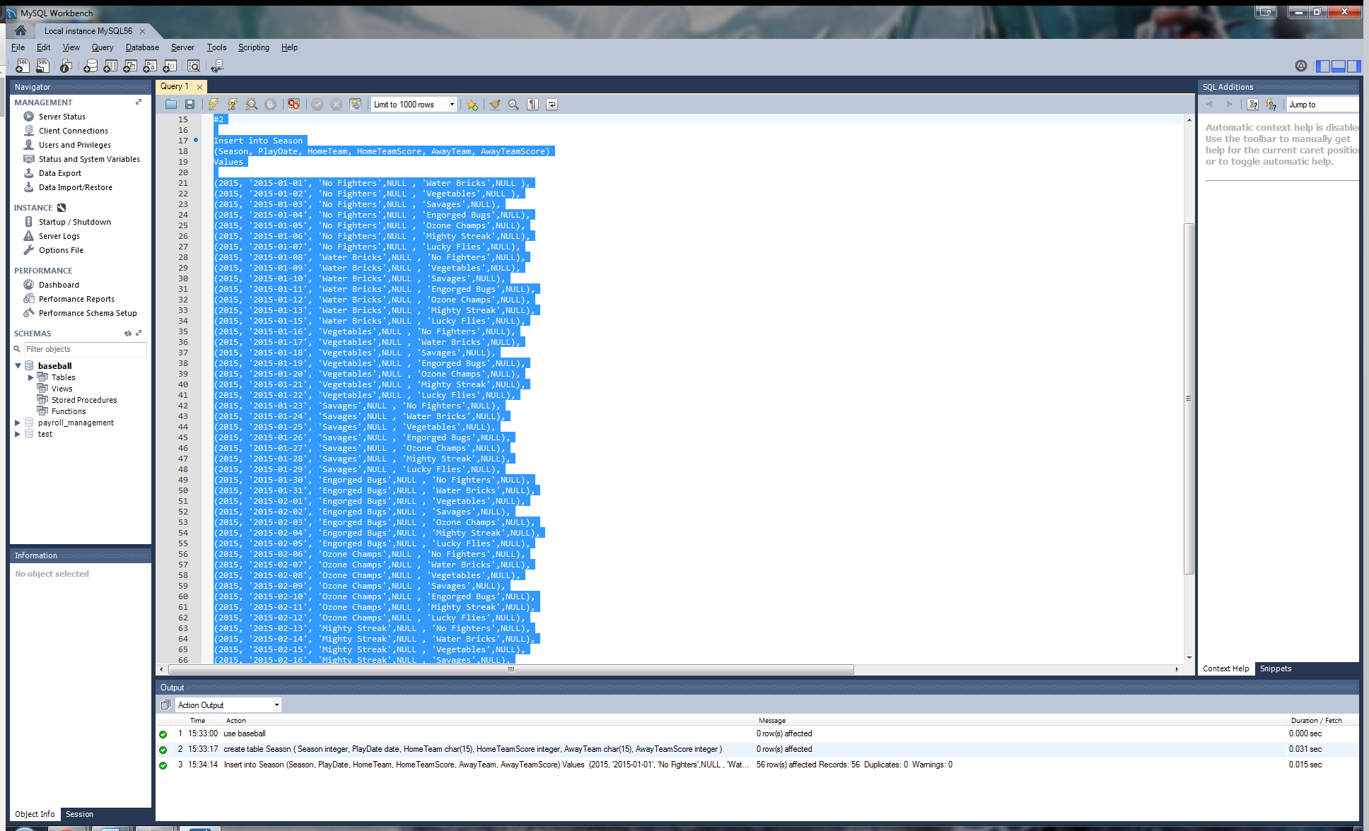

#3

create table PastSeasons as select * from Season;

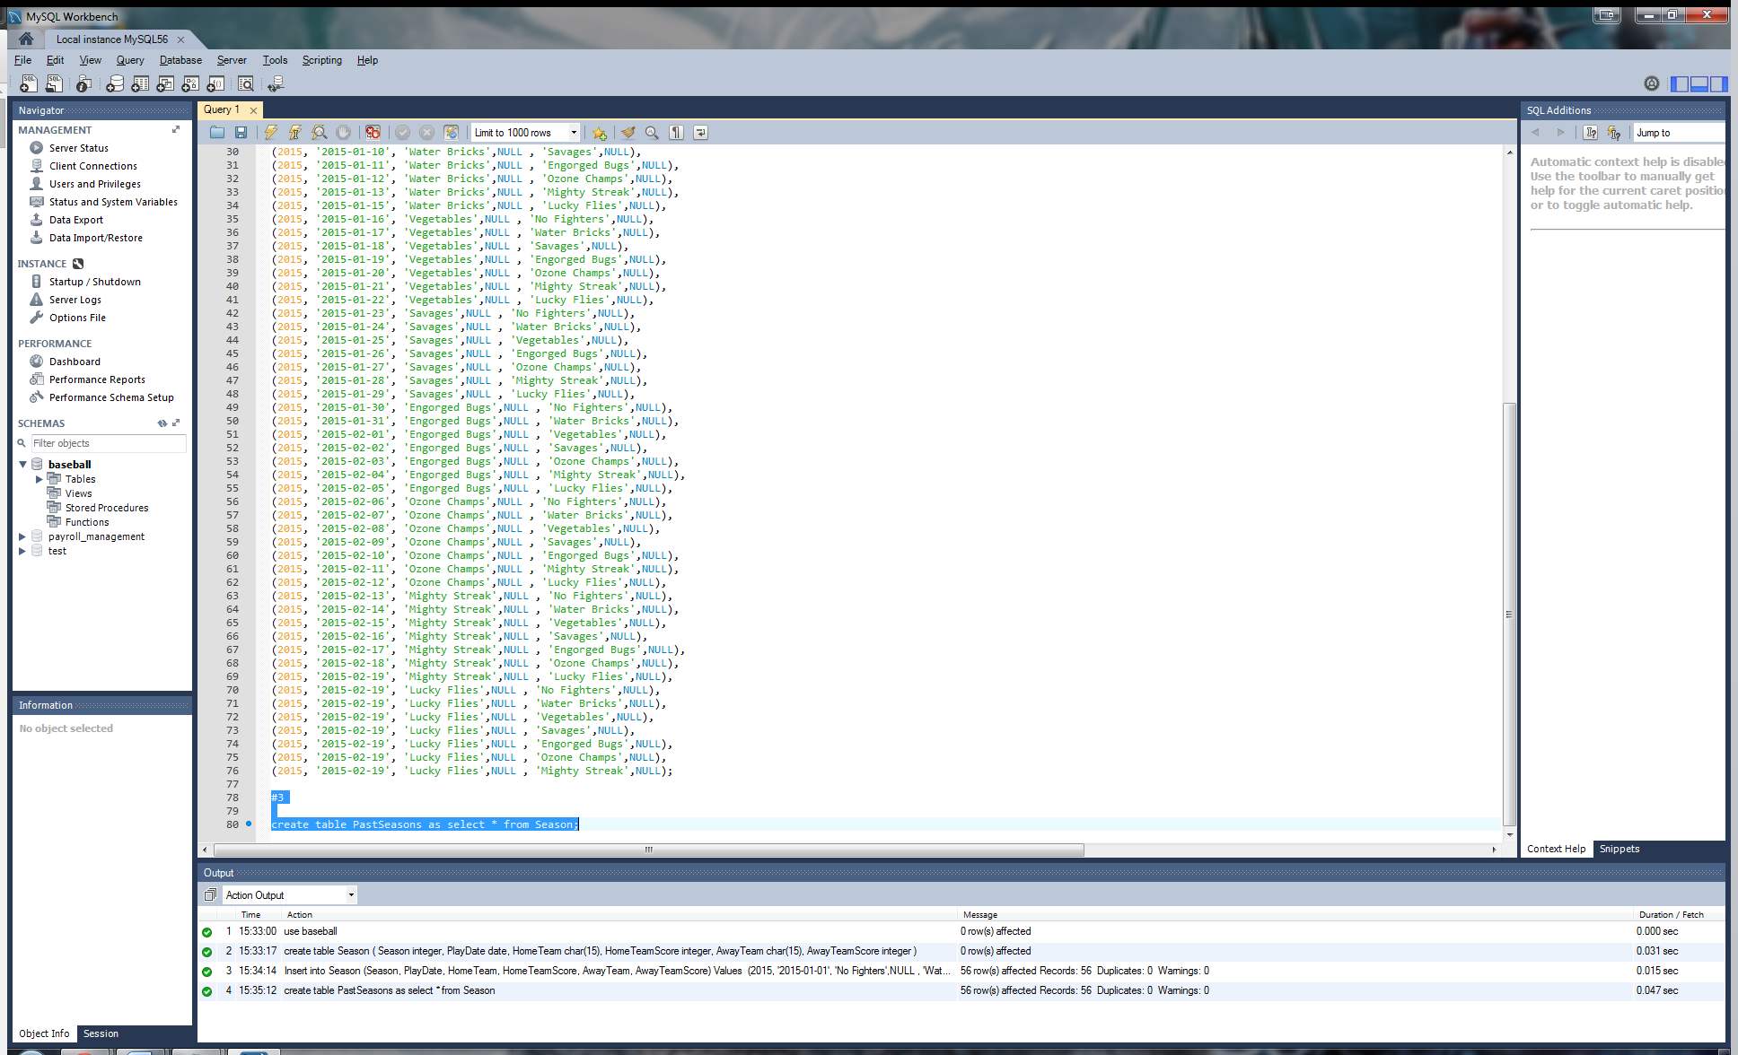

#4

update Season

set Season = 2016

where Season = 2015

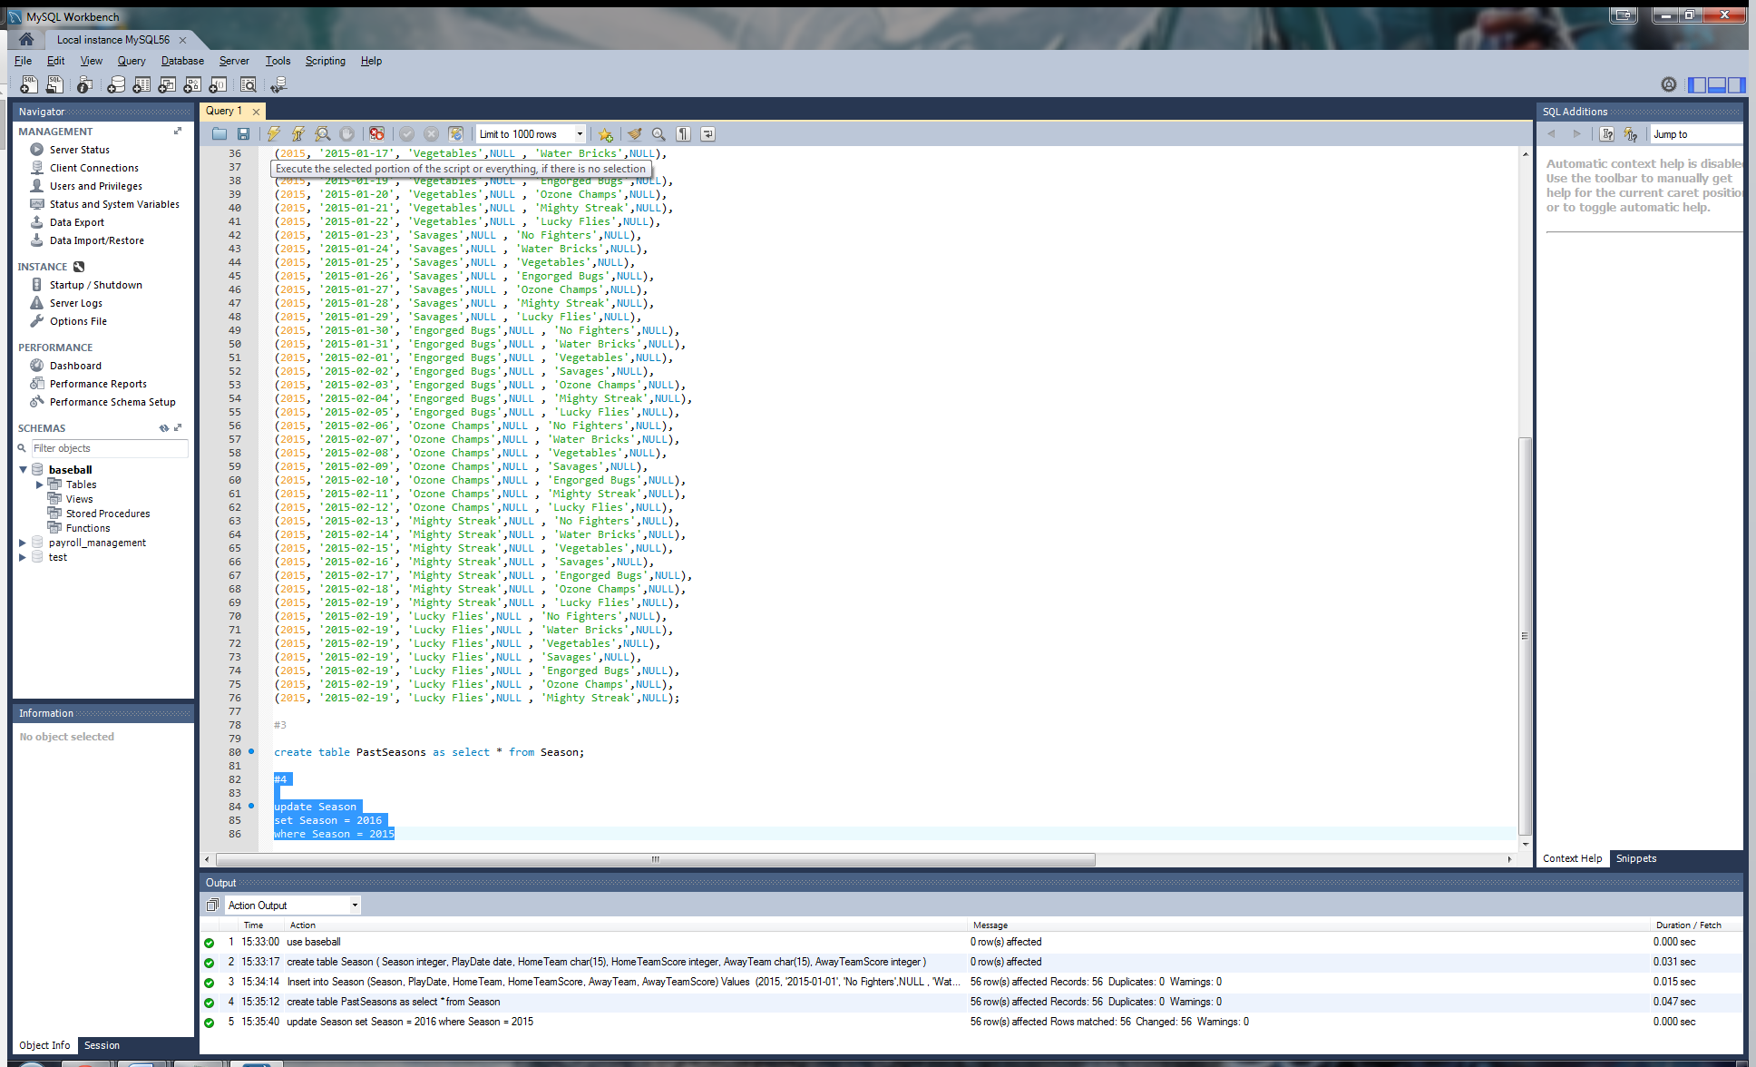

#5

select * into outfile 'LAB_3_datafile.txt.txt'

fields terminated by ','

from Season;

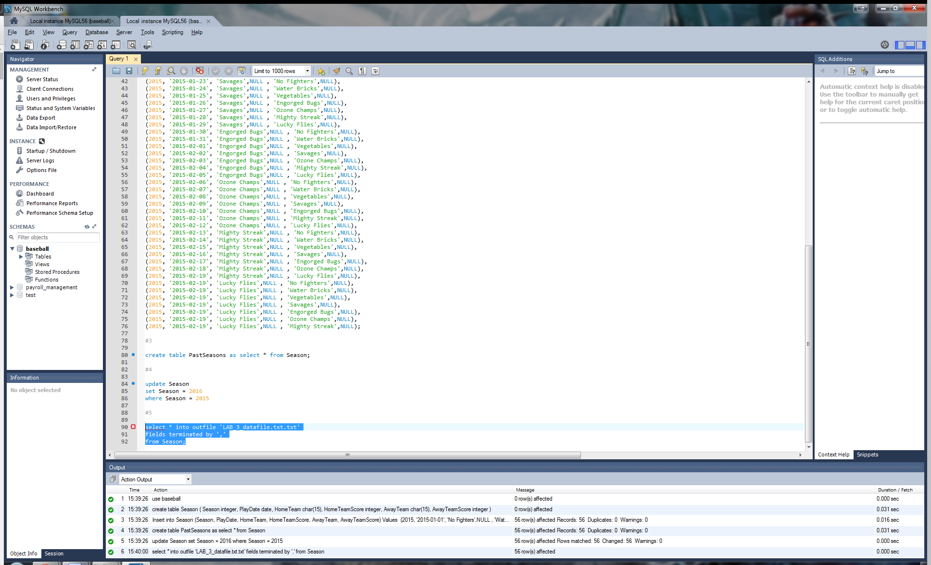

#6

load data infile 'LAB_3_datafile.txt' into table PastSeasons

fields terminated by ','

enclosed by '"'

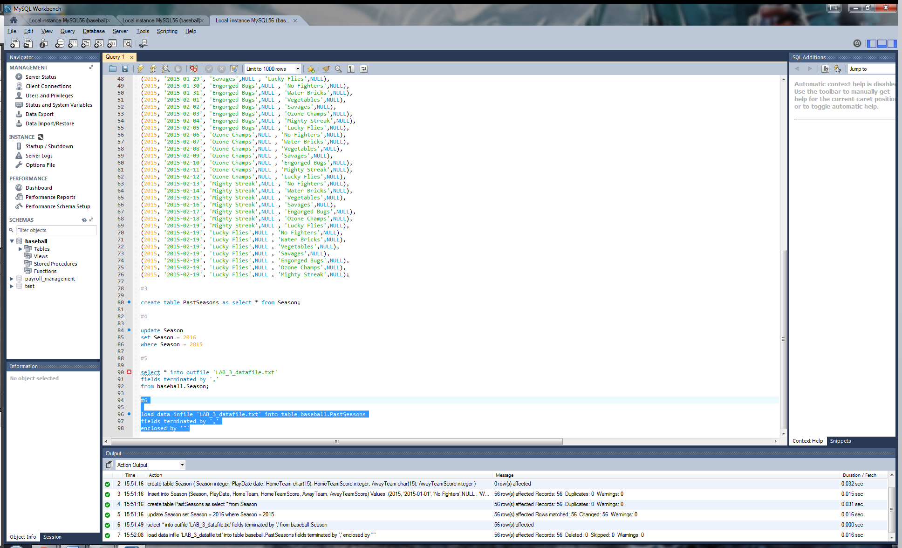

**Conclusions:** After completing this lab, in your own words, what conclusions can you draw from this experience?

Through my experience with this lab and researching and then practicing the concepts involved, I learned some new and very beneficial statements and syntax for MySQL. Ultimately efficiency and ease was the pinnacle of what this lab and its concepts had to offer. The ability to create a table based off either the structure, or structure and full data, of another table is very handy in being efficient in database creation and management. In addition, the concept and ability of loading and unloading files can help again with time and efficiency since data can be easily typed in another application such as notepad simply separated by commas, and then can be quickly loaded into MySQL and formatted appropriately for use in the database. Update statements are again about efficiency and ease, but this was not a new concept to me, just a refresh in terms of learning how to use it properly in MySQL syntax.

|  |  |  |  |  |  |
| --- | --- | --- | --- | --- | --- |
| **Student:** | Anthony Meunier |  | CIS |  | Anthony Meunier |
|  | Name |  | Program |  | Signature |